**HRMS MAXX RECOVERY**

In descending order of priority

1. **DO NOT IMPLEMENT 2nd SESSION IN SHIFTS, WE’VE THOUGHT A NEW WAY TO MODELATE DOUBLE SESSION SHIFTS AND FREE SHIFTS (E.G. A TEACHER THAT HAS DIFFERENTS SHIFTS PER DAY).**

We will write a document with everything explained next Monday.

For now, we only need shifts with **1 session** with **break time** with an **optional range (e.g. from 12:00 to 13:00**) to take the break. The most important thing we need it’s **that an employee to be able to have multiple shifts.**

* 1 SESSION SHIFTS
* BREAK TIME
* OPTIONAL RANGE
* MORE THAN 1 SHIFT FOR AN EMPLOYEE

1. **DATA IMPORT NOT WORKING.**

On Wednesday we have an important meeting with a client, we will train them with the system. Its crucial that data import from excel files works.

1. **BUG: Shifts Data Import .**

In the system when we try to import the shifts from the excel file, the columns “MIN END TIME” and “END TIME” show different values than the excel sheet.

***Excel Sheet: 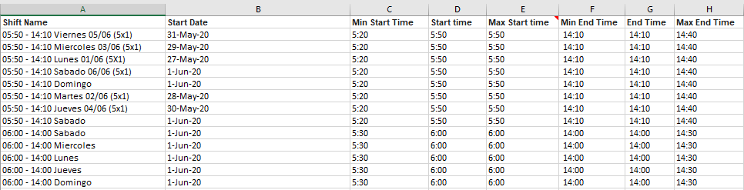System (HRMS MAXX):***

